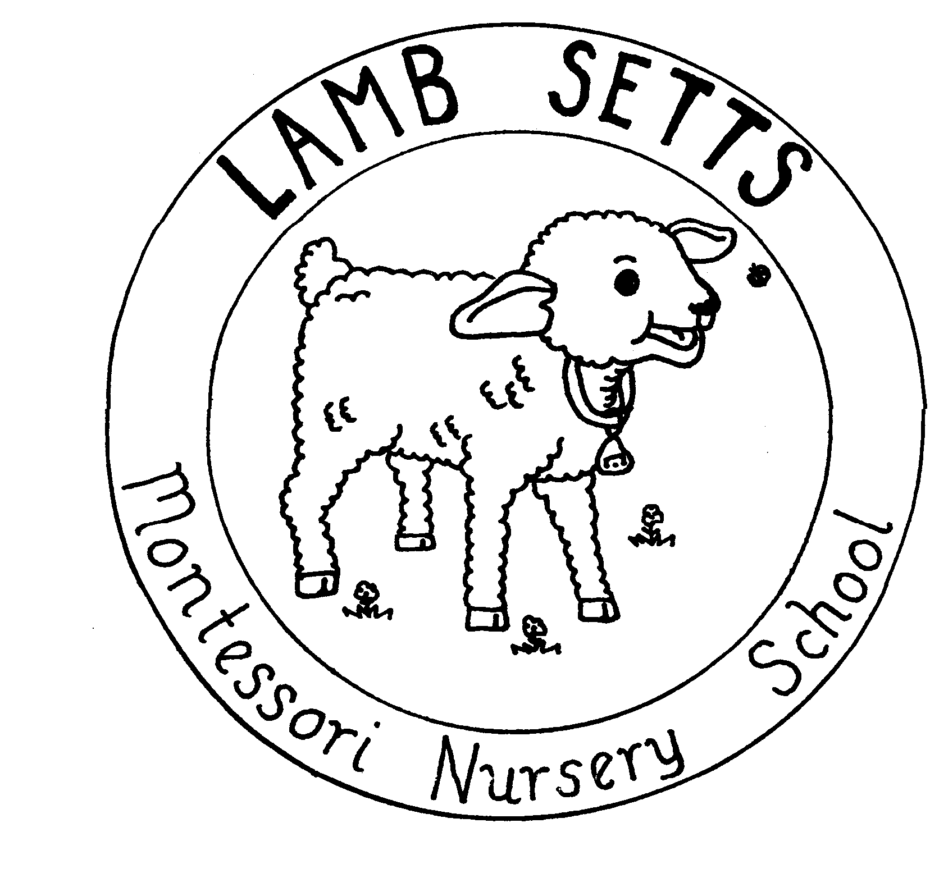
LAMB SETTS NURSERY
Chesterfield Application Form

CHILD'S NAME______________________________________
Date of birth ______________________________________

NAME OF PARENT OR GUARDIAN;
MR MRS MS MISS __________________________________
ADDRESS __________________________________
__________________________________
__________________________________
POST CODE __________________________________
TEL.NUMBER __________________________________

Children who are 2*3 and 4 years old are entitled to

15/30* hours free childcare and education per week in term time
*Some 2 year olds are eligible for 15 hours free childcare and education per week
* Some 3 and 4 year olds are eligible for up to 30 hours free childcare and education per week.
Session | Time | Mon | Tues | Wed | Thurs | Fri
Mornings | 08.45-11.45
Lunch Time Care* | 11.45-12.30
Afternoons | 12.30-3.30

Start date required: ____________________________________
Please return this form to;
Lamb Setts Nursery c/o Christ Church C of E Primary School, Tapton View Road, Stonegravels, Chesterfield, S41 7JU. 01246 520400 File ref: Chesterfield Brochure

Terms and Conditions

Fees: Fees are payable monthly in advance on or before the first of the month. Invoices will be issued. Late payments will incur a 5% surcharge. Late payments must be made in cash. Acceptable methods of payment are cash, cheque and selected vouchers.
Fees are calculated on the basis of a full year and therefore there are no reductions for Bank Holidays or the Christmas shut down week. There are no reductions for sessions missed due to family holiday or illness. Lamb Setts accepts all the main nursery voucher schemes. Discounts will be offered to families where more than one child attends full-time.
One months notification, in writing, is required to terminate a place.
Unpaid fees:
Lamb Setts will pursue unpaid fees through the small claims court
Deposits: A non-refundable deposit is required to secure a fee paying place, deposits are not required to secure a Government Funded place.
Recommendations: A voucher for a free session will be issued to any parent who recommends a new client. (Please ensure your details are added to the application form of the new client at the time of the new application)
Food/Nappies: Food and nappies are provided for fee paying places at no extra cost. For funded places there is a small charge for snacks and if children are staying over the lunchtime period, they are required to bring a packed lunch.
Special Diets: If a child requires a special diet, this should be provided by parents/carers and Lamb Setts staff will prepare and serve this.
Contact Details: Parents/carers are expected to provide up to date contact details so that they are contactable at all times when their child is attending Lamb Setts.
Parental Responsibility: All forms must be signed by persons with parental responsibility.
Sickness: There are no reductions for sessions missed due to illness. Parents/carers are not expected to bring children to nursery when they are unwell. Staffing ratios are not sufficient to effectively care for ill children. Parents/carers are expected to collect children as soon as possible if they become unwell at nursery. A list of illnesses which prevent children from attending are displayed in each unit.
Medication: Lamb Setts staff are unable to administer medication which has not been prescribed by a doctor, however, staff are able to administer medication which has been prescribed by a doctor. Parents/carers will need to complete a medication form.
Drop Off/Collection: Parents/carers are expected to drop off and collect children within the specified session times.
Late Collections: On the first late collection parents/carers will be issued with a warning. On any subsequent late collections parents will incur a substantial late collection fee.

I agree to the above terms and conditions.
Signed: __________________________ Print name:___________________

